- EnergyManagementSystem

abstract class EnergySource
{
int source_id;
String source_name;
double energy_generated;
//Using Constructor
EnergySource(int source_id, String source_name, double energy_generated)
{
this.source_id=source_id;
this.source_name=source_name;
this.energy_generated=energy_generated;
}
//abstract method
abstract double calculateEfficiency();
//To display Details
void displayDetails()
{
System.out.println("Name:" + "C T M Varshini");
System.out.println("USN:" + "1BM26CS533-T");
System.out.println("Source ID:" + source_id);
System.out.println("Source Name:" + source_name);
System.out.println("Energy Generated:" + energy_generated + "kwh");
System.out.printf("Efficiency: %.2f\n", calculateEfficiency());
}
}
//use of inheritance
class SolarEnergy extends EnergySource
{
SolarEnergy(int source_id, String source_name, double energy_generated)
{
super(source_id, source_name, energy_generated);
}
double calculateEfficiency()
{
return (energy_generated/5000.0)*100.0;
}
}
//use of inheritance
class WindEnergy extends EnergySource
{
WindEnergy(int source_id, String source_name, double energy_generated)
{
super(source_id, source_name, energy_generated);
}
double calculateEfficiency()
{
return (energy_generated/8000.0)*100.0;
}
}
public class EnergyManagementSystem
{
public static void main (String[] args)
{
EnergySource ref;
ref = new SolarEnergy(101, "varsha", 1250);
ref.displayDetails();
ref = new WindEnergy(102, "varshini", 1350);
ref.displayDetails();
}
}
Output
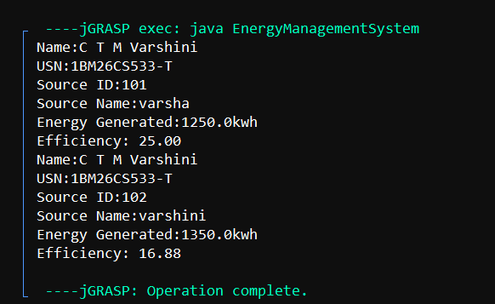
- ParkingManagementSystem

interface ParkingCharge
{
double calculateCharge();
void displayParkingDetails();
}
class VehicleParking
{
String vehicle_number;
String vehicle_type;
int parking_hours;
public VehicleParking(String vehicle_number, String vehicle_type, int parking_hours) {
this.vehicle_number = vehicle_number;
this.vehicle_type = vehicle_type;
this.parking_hours = parking_hours;
}
}
class TwoWheeler extends VehicleParking implements ParkingCharge
{
public TwoWheeler(String vehicle_number, int parking_hours)
{
super(vehicle_number, "Two Wheeler", parking_hours);
}
public double calculateCharge()
{
if (parking_hours <= 2)
{
return parking_hours * 20.0;
}
else
{
return (2 * 20.0) + ((parking_hours - 2) * 10.0);
}
}
public void displayParkingDetails()
{
System.out.println("Vehicle Number: " + vehicle_number);
System.out.println("Vehicle Type: " + vehicle_type);
System.out.println("Parking Hours: " + parking_hours + " hrs");
System.out.println("Total Parking Charge: Rs. " + calculateCharge());
}
}
class FourWheeler extends VehicleParking implements ParkingCharge
{
public FourWheeler(String vehicle_number, int parking_hours)
{
super(vehicle_number, "Four Wheeler", parking_hours);
}
public double calculateCharge()
{
if (parking_hours <= 2)
{
return parking_hours * 50.0;
}
else
{
return (2 * 50.0) + ((parking_hours - 2) * 30.0);
}
}
public void displayParkingDetails()
{
System.out.println("Vehicle Number: " + vehicle_number);
System.out.println("Vehicle Type: " + vehicle_type);
System.out.println("Parking Hours: " + parking_hours + " hrs");
System.out.println("Total Parking Charge: Rs. " + calculateCharge());
}
}
public class ParkingManagementSystem
{
public static void main(String[] args)
{
ParkingCharge parkingRef;
parkingRef = new TwoWheeler("KA-01-AB-1234", 5);
parkingRef.displayParkingDetails();
parkingRef = new FourWheeler("KA-05-CD-5678", 4);
parkingRef.displayParkingDetails();
}
}

Output
